Submitting the Annual SWaM Report

*(Only SWaM Plan Administrators have this capability)*

Contents

Navigating to the Annual SWaM Report 2

Submitting the Annual SWaM Report 3

Submitting the Annual SWaM Report

*(Only SWaM Plan Administrators have this capability)*

# Navigating to the Annual SWaM Report

1. Log into Dashboard using state e-mail address and password. Click Login.

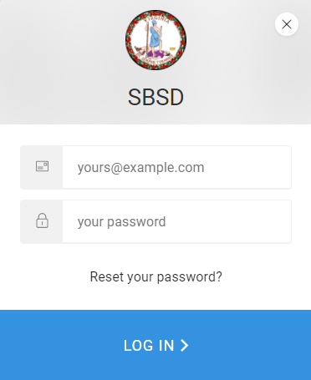

1. Click SWaM Plan Tab at top of Page.

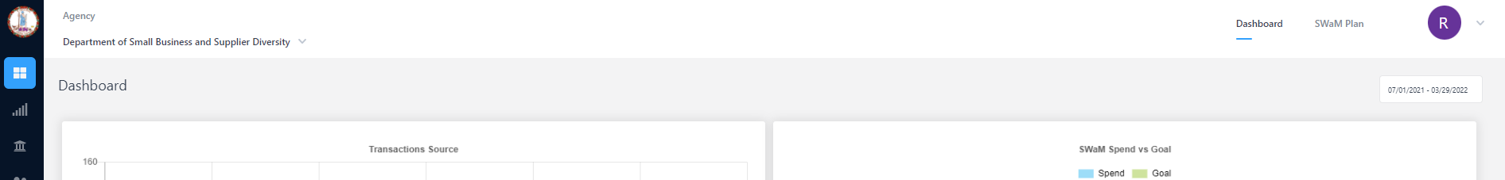



1. You will see a page that has information about when the SWaM Plan was published and who it was published by. Click on the eyeball icon under actions.

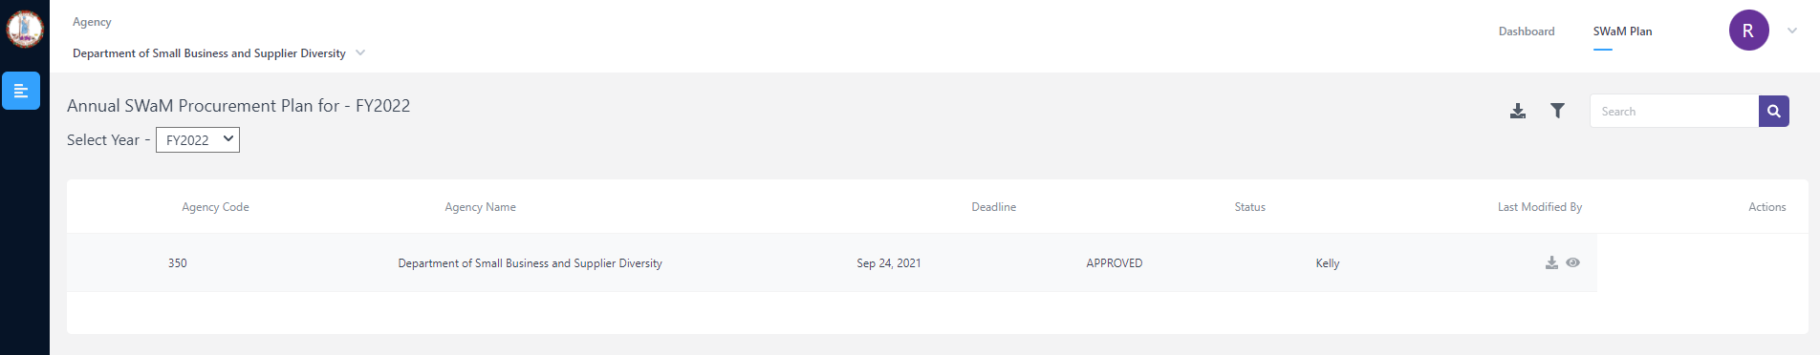



1. You will now see the instructions page for completing the Annual SWaM Report. Click on the “Proceed to Form” button.

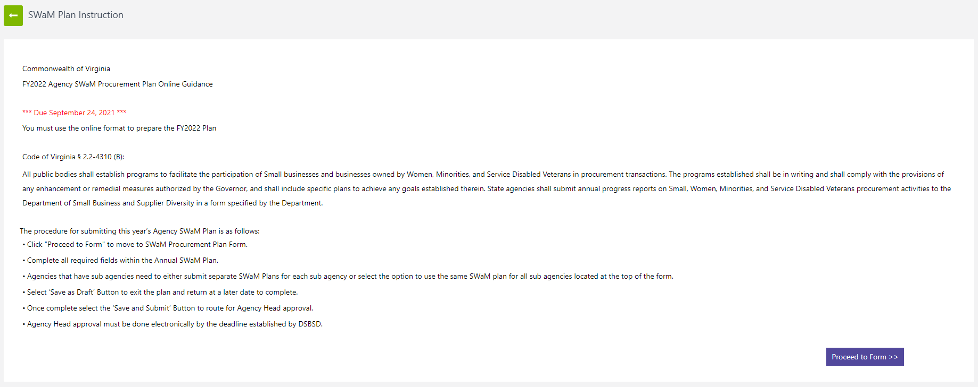

# Submitting the Annual SWaM Report

1. You will now be on your agency’s Annual SWaM Report. If you are a parent agency completing the plan on behalf of all of your sub agencies. There will be a box to click near the top of the page.

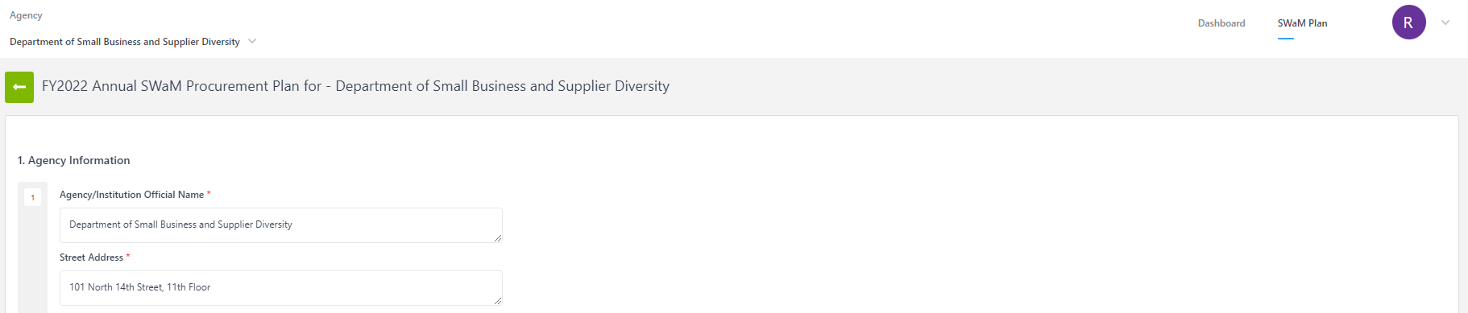

1. Complete the Annual SWaM Report. There is a save as Draft button if you want to save the Plan as a draft and come back to it later. 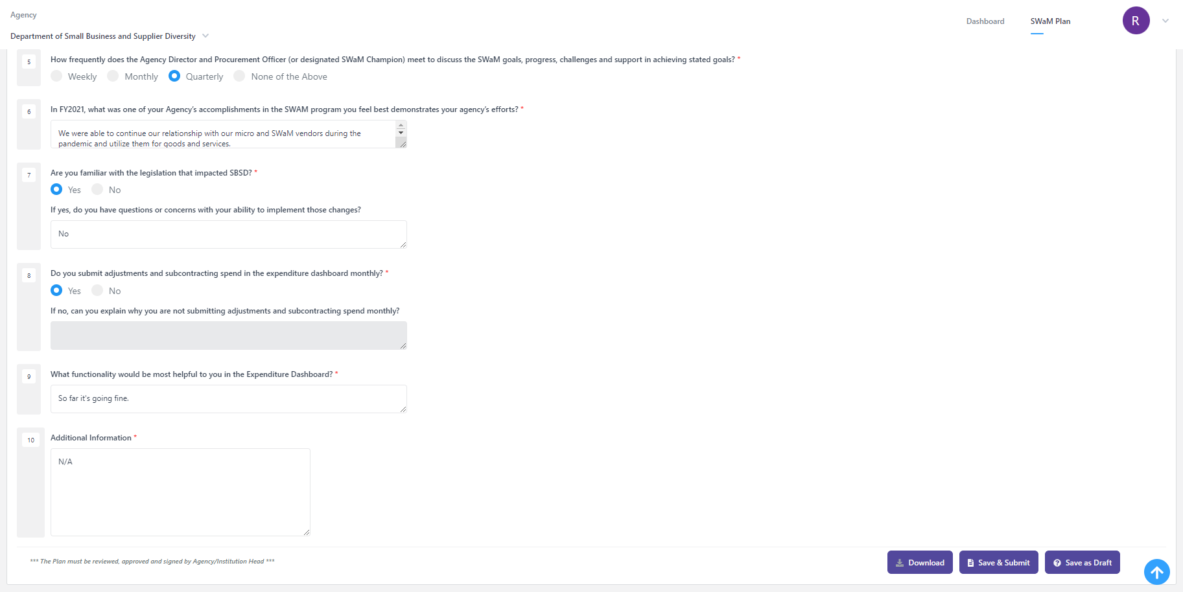
2. When you have completed your Annual SWaM Report, click the Submit and Approve button. You will be able to sign the Annual SWaM Report and it will be electronically sent to your agency head for them to approve.



1. Once your agency head has electronically signed the Annual SWaM Report, it will be submitted to DSBSD electronically.